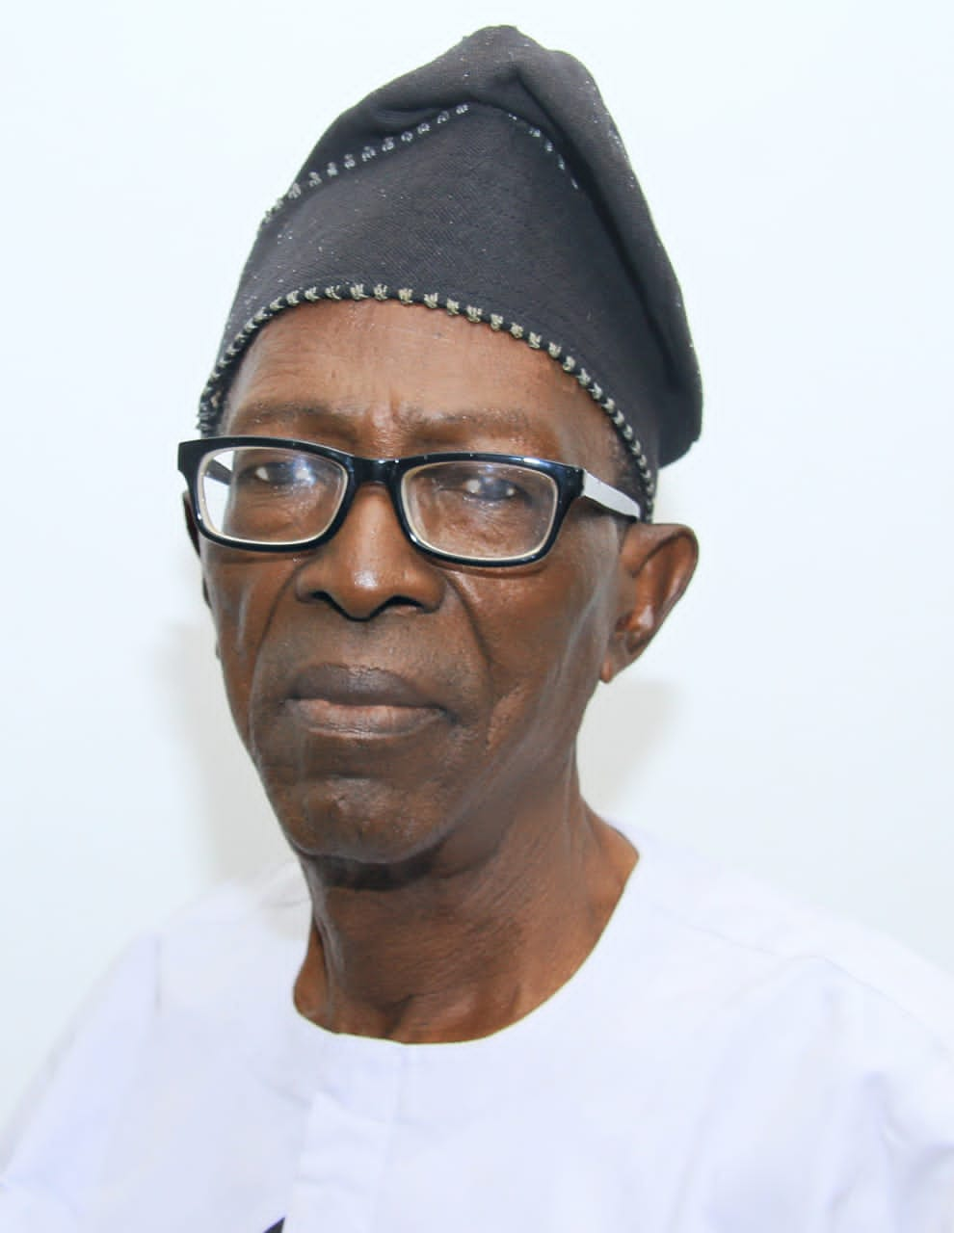

**ELDER OLASUNKANMI AJAO, ELDER-IN-COUNCIL**